Name: Abhinay P
Domain: Data Analyst
Project: Power BI Snapdeal Project
Task 3: To compare Average Price vs Average Subcategory. Which chart type would you use and why? How would you interpret the results if expensive categories have lower ratings?
Answer:
A Column and Line combo Chart is the most Suitable visual to compare Average Price and Average Rating across Subcategories.
Explanation:
A combo chart allows two different metrics with different scales to be visualized together. In this chart, Average Price is displayed using columns, while Average Rating is represented using a line on a secondary axis. This enables clear comparison of pricing and customer satisfaction across subcategory without scale distortion.

Interpretation: Average Price vs Average Rating by Subcategory
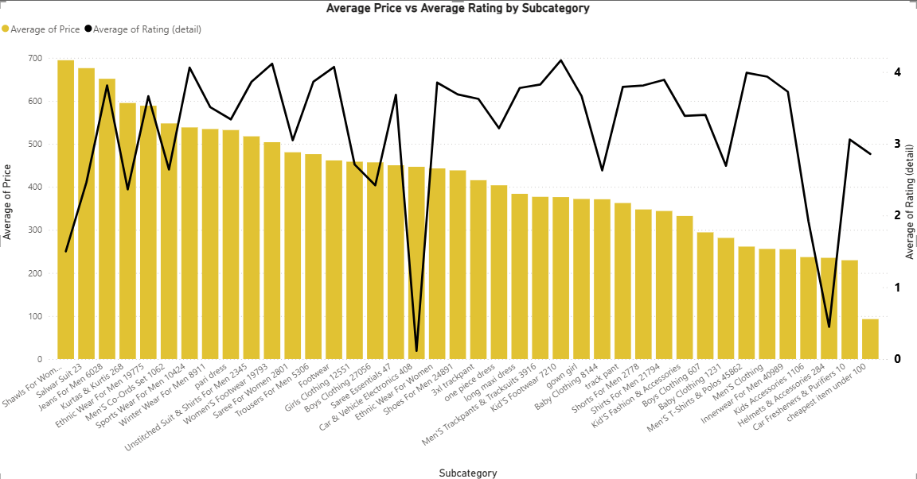
The combo chart compares Average Price (Columns) and Average Rating (Line) across different product subcategories. From the Visualization, it is evident that higher average prices do not consistently correspond to higher customer ratings.
Several high-priced subcategories show moderate or fluctuating ratings, indicating that premium pricing does not always guarantee higher customer satisfaction. Conversely, some mis and lower priced subcategories maintain stable or relatively high ratings, suggesting better perceived value for money.
Notably, a few subcategories exhibit sharp drops in average ratings despite comparable price levels, which may point to quality issues, unmet customer expectations, or product price mismatch. Overall, the chart highlights that customer satisfaction is influenced by factors beyond price, emphasizing the importance of quality, usability, and experience in driving ratings.

Insight:
This suggests that e-commerce managers should not solely rely on premium pricing strategies but should focus on improving product quality and customer experience, especially in high-priced categories with lower ratings.

